 PRIORITY
Enterprise Management System

Web-site (CMS) Module

OVERVIEW
Business improvement for all organisations today means getting closer to your customers. In today’s technology-centric world this means allowing maximum communication with your customers through your web-site. When you are managing your business data in an integrated solution such as Priority, it is imperative that your web-site is part of that integrated picture.

 Web tools to extend your Priority solution.

- CMS to ease the management of your web-site.

 Ensure your web-site contains up-to-date information direct from Priority.

CONTENT MANAGEMENT SYSTEM
The Emerge CMS for Priority provides the basis for your web presence. It is a template driven Content Management System to allow you to easily manage day-to-day content changes in-house. This is beneficial in a wide range of scenarios, including where a company maintains multiple web-sites or micro-sites.

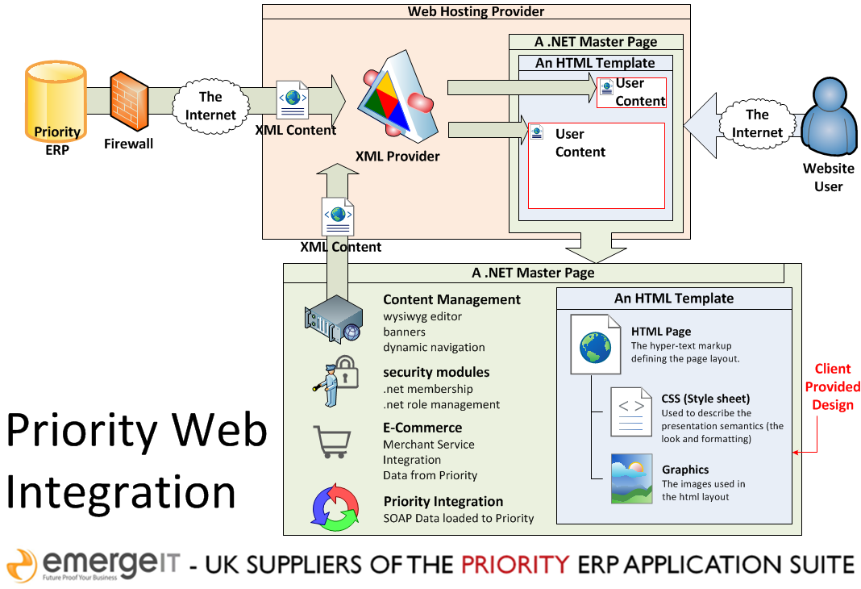

REAL TIME DATA FOR YOUR CUSTOMERS
The Emerge CMS for Priority links data directly from your ERP via XML feed. You can also use these data feeds to provide data to any other pre-existing web-site. We are happy to link your Priority data to your existing web-site and to work with your existing web design authority.

REAL TIME DATA ENTRY
Many organisations are not just happy with providing data to customers in a one-way communication. They need to receive orders and quotation requests from their customers via the web-site. The simple management of product data within Priority and the ability to easily identify those products that need to appear on the web-site means that wholesale periodic data-loading is not required. Customer logins are a standard feature and the immediate update to the background Priority system means that yours customers orders and requests appear instantaneously in your business management system.

Allow your customers and prospects to interact with your back-office system via your web-site in a perfectly secure environment.

 Accept payment via your web-site using standard secure payment methods.

 Maximum flexibility with maximum capability.

PAYMENT SYSTEMS
Where you wish your customers to order products from your web-site, if you are dealing with end consumers (and sometimes when operating B2B), you will require the payment of the goods and services by credit card to confirm the order. All the standard web payment systems can be operated via both the Emerge CMS option and any in-house web design.

FLEXIBILITY
The well-known Priority flexibility has been ported across to the Emerge CMS solution. The emphasis with this tool, is to ensure any modifications can be designed and enacted with the lowest possible skill-level. We don’t require you to employ specialist web-designers to maintain your web-site. Once you have designed your template we’ve done all the background work to ensure that content management can be maintained in-house.

eMerge Information Technology Limited
Speedwell House, Speedwell Close Tel: +44 (0)845 230 6740

Chandlers Ford Industrial Estate Fax: +44 (0)845 230 6750
Chandlers Ford, Hampshire www.emerge-it.co.uk
SO53 4BT info@emerge-it.co.uk

